Trabajo Práctico N° 6:
Integrales.

Ejercicio 1.

(a) Si $\int_{0}^{9}{f (x) dx}$= 37 y $\int_{0}^{9}{g (x) dx}$= 16, encontrar el valor de $\int_{0}^{9}{2 f (x) -\frac{1}{4} g (x) dx}$.

$\int_{0}^{9}{2 f (x)-\frac{1}{4} g (x) dx}$= $\int_{0}^{9}{2 f (x) dx}$ + $\int_{0}^{9}{\frac{-1}{4} g (x) dx}$
$\int_{0}^{9}{2 f (x)-\frac{1}{4} g (x) dx}$= 2 $\int_{0}^{9}{f (x) dx}$ - $\frac{1}{4}$ $\int_{0}^{9}{g (x) dx}$
$\int_{0}^{9}{2 f (x)-\frac{1}{4} g (x) dx}$= 2 * 37 - $\frac{1}{4}$ * 16
$\int_{0}^{9}{2 f (x)-\frac{1}{4} g (x) dx}$= 74 - 4
$\int_{0}^{9}{2 f (x)-\frac{1}{4} g (x) dx}$= 70.

(b) Si $\int_{-2}^{3}{h (x) dx}$= 12 y $\int_{0}^{3}{h (x) dx}$= 3, hallar el valor de $\int_{-2}^{0}{h (x) dx}$.

$\int_{-2}^{0}{h (x) dx}$= $\int_{-2}^{3}{h (x) dx}$ - $\int_{0}^{3}{h (x) dx}$
$\int_{-2}^{0}{h (x) dx}$= 12 - 3
$\int_{-2}^{0}{h (x) dx}$= 9.

(c) Si $\int_{-1}^{3}{f (t) dt}$= 3 y $\int_{-1}^{4}{f (t) dt}$= 7, determinar el valor de $\int_{3}^{4}{f (t) dt}$.

$\int_{3}^{4}{f (t) dt}$= $\int_{-1}^{4}{f (t) dt}$ - $\int_{-1}^{3}{f (t) dt}$
$\int_{3}^{4}{f (t) dt}$= 7 - 3
$\int_{3}^{4}{f (t) dt}$= 4.
Ejercicio 2.

Calcular las siguientes integrales utilizando las propiedades y, en caso de ser posible, usando la regla de Barrow.

(a) $\int_{-2}^{3}{2x-1 dx}$.

$\int_{-2}^{3}{2x-1 dx}$= $\int_{-2}^{3}{2x dx}$ + $\int_{-2}^{3}{-1 dx}$
$\int_{-2}^{3}{2x-1 dx}$= 2 $\int_{-2}^{3}{x dx}$ - $\int_{-2}^{3}{1 dx}$
$\int_{-2}^{3}{2x-1 dx}$= 2 $\frac{x^{2}}{2}$ $|_{-2}^{3}$ - x $|_{-2}^{3}$
$\int_{-2}^{3}{2x-1 dx}$= $x^{2}$ $|_{-2}^{3}$ - [3 - (-2)]
$\int_{-2}^{3}{2x-1 dx}$= [$3^{2}$ - ${(-2)}^{2}$] - (3 + 2)
$\int_{-2}^{3}{2x-1 dx}$= (9 - 4) - 5
$\int_{-2}^{3}{2x-1 dx}$= 5 - 5
$\int_{-2}^{3}{2x-1 dx}$= 0.

(b) $\int{x^{2}+2x+8 dx}$.

$\int{x^{2}+2x+8 dx}$= $\int{x^{2} dx}$ + $\int{2x dx}$ + $\int{8 dx}$
$\int{x^{2}+2x+8 dx}$= $\frac{x^{3}}{3}$ + 2 $\int{x dx}$ + 8 $\int{1 dx}$
$\int{x^{2}+2x+8 dx}$= $\frac{x^{3}}{3}$ + 2 $\frac{x^{2}}{2}$ + 8x
$\int{x^{2}+2x+8 dx}$= $\frac{x^{3}}{3}$ + $x^{2}$ + 8x + C.

(c) $\int_{0}^{2π}{sen x+x dx}$.

$\int_{0}^{2π}{sen x+x dx}$= $\int_{0}^{2π}{sen x dx}$ + $\int_{0}^{2π}{x dx}$
$\int_{0}^{2π}{sen x+x dx}$= -cos x $|_{0}^{2π}$ + $\frac{x^{2}}{2}$ $|_{0}^{2π}$
$\int_{0}^{2π}{sen x+x dx}$= -(cos 2$π$ - cos 0) + $\frac{1}{2}$ [${(2π)}^{2}$ - $0^{2}$]
$\int_{0}^{2π}{sen x+x dx}$= -(1 - 1) + $\frac{1}{2}$ (4$π^{2}$ - 0)
$\int_{0}^{2π}{sen x+x dx}$= -0 + $\frac{1}{2}$ 4$π^{2}$
$\int_{0}^{2π}{sen x+x dx}$= 2$π^{2}$.

(d) $\int_{0}^{4}{2e^{x}+3x^{4} dx}$.

$\int_{0}^{4}{2e^{x}+3x^{4} dx}$= $\int_{0}^{4}{2e^{x} dx}$ + $\int_{0}^{4}{3x^{4} dx}$
$\int_{0}^{4}{2e^{x}+3x^{4} dx}$= 2 $\int_{0}^{4}{e^{x} dx}$ + 3 $\int_{0}^{4}{x^{4} dx}$
$\int_{0}^{4}{2e^{x}+3x^{4} dx}$= 2$e^{x}$ $|_{0}^{4}$ + 3 $\frac{x^{5}}{5}$ $|_{0}^{4}$
$\int_{0}^{4}{2e^{x}+3x^{4} dx}$= 2 ($e^{4}$ - $e^{0}$) + $\frac{3}{5}$ ($4^{5}$ - $0^{5}$)
$\int_{0}^{4}{2e^{x}+3x^{4} dx}$= 2 ($e^{4}$ - 1) + $\frac{3}{5}$ (1024 - 0)
$\int_{0}^{4}{2e^{x}+3x^{4} dx}$= 2$e^{4}$ - 2 + $\frac{3}{5}$ * 1024
$\int_{0}^{4}{2e^{x}+3x^{4} dx}$= 2$e^{4}$ - 2 + $\frac{3072}{5}$
$\int_{0}^{4}{2e^{x}+3x^{4} dx}$= $\frac{10e^{4}+3062}{5}$.

(e) $\int{3\frac{1}{x}+2e^{x} dx}$.

$\int{3\frac{1}{x}+2e^{x} dx}$= $\int{3\frac{1}{x} dx}$ + $\int{2e^{x} dx}$
$\int{3\frac{1}{x}+2e^{x} dx}$= 3 $\int{\frac{1}{x} dx}$ + 2 $\int{e^{x} dx}$
$\int{3\frac{1}{x}+2e^{x} dx}$= 3 ln $\left|x\right|$ + 2$e^{x}$ + C.

(f) $\int{\cos{x}+sen x+2x^{\frac{3}{5}} dx}$.

$\int{\cos{x}+sen x+2x^{\frac{3}{5}} dx}$= $\int{\cos{x} dx}$ + $\int{sen x dx}$ + $\int{2x^{\frac{3}{5}} dx}$
$\int{\cos{x}+sen x+2x^{\frac{3}{5}} dx}$= sen x - cos x + 2 $\int{x^{\frac{3}{5}} dx}$
$\int{\cos{x}+sen x+2x^{\frac{3}{5}} dx}$= sen x - cos x + 2 $\frac{x^{\frac{8}{5}}}{\frac{8}{5}}$
$\int{\cos{x}+sen x+2x^{\frac{3}{5}} dx}$= sen x - cos x + $\frac{5}{4}$ $x^{\frac{8}{5}}$ + C.

(g) $\int_{-5}^{1}{x^{2}+2x+8 dx}$.

$\int_{-5}^{1}{x^{2}+2x+8 dx}$= $\int_{-5}^{1}{x^{2} dx}$ + $\int_{-5}^{1}{2x dx}$ + $\int_{-5}^{1}{8 dx}$
$\int_{-5}^{1}{x^{2}+2x+8 dx}$= $\frac{x^{3}}{3}$ $|_{-5}^{1}$ + 2 $\int_{-5}^{1}{x dx}$ + 8 $\int_{-5}^{1}{1 dx}$
$\int_{-5}^{1}{x^{2}+2x+8 dx}$= $\frac{1}{3}$ [$1^{3}$ - ${(-5)}^{3}$] + 2 $\frac{x^{2}}{2}$ $|_{-5}^{1}$ + 8 x $|_{-5}^{1}$
$\int_{-5}^{1}{x^{2}+2x+8 dx}$= $\frac{1}{3}$ [1 - (-125)] + [$1^{2}$ - ${(-5)}^{2}$] + 8 [1 - (-5)]
$\int_{-5}^{1}{x^{2}+2x+8 dx}$= $\frac{1}{3}$ (1 + 125) + (1 - 25) + 8 (1 + 5)
$\int_{-5}^{1}{x^{2}+2x+8 dx}$= $\frac{1}{3}$ * 126 - 24 + 8 * 6
$\int_{-5}^{1}{x^{2}+2x+8 dx}$= $\frac{126}{3}$ - 24 + 48
$\int_{-5}^{1}{x^{2}+2x+8 dx}$= 66.

(h) $\int{x-x^{\frac{2}{5}}+3e^{x}-\cos{x} dx}$.

$\int{x-x^{\frac{2}{5}}+3e^{x}-\cos{x} dx}$= $\int{x dx}$ + $\int{-x^{\frac{2}{5}} dx}$ + $\int{3e^{x} dx}$ + $\int{-\cos{x} dx}$
$\int{x-x^{\frac{2}{5}}+3e^{x}-\cos{x} dx}$= $\frac{x^{2}}{2}$ - $\int{x^{\frac{2}{5}} dx}$ + 3 $\int{e^{x} dx}$ - $\int{\cos{x} dx}$
$\int{x-x^{\frac{2}{5}}+3e^{x}-\cos{x} dx}$= $\frac{x^{2}}{2}$ - $\frac{x^{\frac{7}{5}}}{\frac{7}{5}}$ + 3$e^{x}$ - sen x
$\int{x-x^{\frac{2}{5}}+3e^{x}-\cos{x} dx}$= $\frac{1}{2}$ $x^{2}$ - $\frac{5}{7}$ $x^{\frac{7}{5}}$ + 3$e^{x}$ - sen x + C.
Ejercicio 3.

Calcular las siguientes integrales utilizando los métodos vistos.

(a) $\int{{(3x^{4}+5x^{2}+8)}^{4}(12x^{3}+10x) dx}$.

$\int{{(3x^{4}+5x^{2}+8)}^{4}(12x^{3}+10x) dx}$= $\int{u^{4} du}$ (*)
$\int{{(3x^{4}+5x^{2}+8)}^{4}(12x^{3}+10x) dx}$= $\frac{u^{5}}{5}$
$\int{{(3x^{4}+5x^{2}+8)}^{4}(12x^{3}+10x) dx}$= $\frac{{(3x^{4}+5x^{2}+8)}^{5}}{5}$ + C.

(*) u= 3$x^{4}$ + 5$x^{2}$ + 8; du= (12$x^{3}$ + 10x) dx.

(b) $\int{x\cos{x} dx}$.

$\int{x\cos{x} dx}$= x sen x - $\int{sen x dx}$ (*)
$\int{x\cos{x} dx}$= x sen x - (-cos x)
$\int{x\cos{x} dx}$= x sen x + cos x + C.

(*) u= x; du= dx; dv= cos x dx; v= sen x.

(c) $\int{x^{3}\ln{x} dx}$.

$\int{x^{3}\ln{x} dx}$= ln x $\frac{x^{4}}{4}$ - $\int{\frac{x^{4}}{4} \frac{1}{x} dx}$ (*)
$\int{x^{3}\ln{x} dx}$= $\frac{x^{4}}{4}$ ln x - $\frac{1}{4}$ $\int{x^{3} dx}$
$\int{x^{3}\ln{x} dx}$= $\frac{x^{4}}{4}$ ln x - $\frac{1}{4}$ $\frac{x^{4}}{4}$
$\int{x^{3}\ln{x} dx}$= $\frac{x^{4}}{4}$ ln x - $\frac{x^{4}}{16}$
$\int{x^{3}\ln{x} dx}$= $\frac{x^{4}}{4}$ (ln x - $\frac{1}{4}$) + C.

(*) u= ln x; du= $\frac{1}{x}$ dx; dv= $x^{3}$ dx; v= $\frac{x^{4}}{4}$.

(d) $\int{\cos{5x}*5 dx}$.

$\int{\cos{5x}*5 dx}$= $\int{\cos{u} du}$ (*)
$\int{\cos{5x}*5 dx}$= sen u
$\int{\cos{5x}*5 dx}$= sen 5x + C.

(*) u= 5x; du= 5 dx.

(e) $\int{\frac{2+e^{x}}{e^{x}+2x}dx}$.

$\int{\frac{2+e^{x}}{e^{x}+2x}dx}$= $\int{\frac{1}{u}du}$ (*)
$\int{\frac{2+e^{x}}{e^{x}+2x}dx}$= ln $\left|u\right|$
$\int{\frac{2+e^{x}}{e^{x}+2x}dx}$= ln $\left|e^{x}+2x\right|$ + C.

(*) u= $e^{x}$ + 2x; du= ($e^{x}$ + 2) dx.

(f) $\int{x\sqrt{x-1} dx}$.

(*) u= $\sqrt{x-1}$; du= $\frac{1}{2\sqrt{x-1}}$ dx.

$\int{x\sqrt{x-1} dx}$= $\int{(u+1)\sqrt{u} du}$ (*)
$\int{x\sqrt{x-1} dx}$= $\int{u^{\frac{3}{2}}+u^{\frac{1}{2}} du}$
$\int{x\sqrt{x-1} dx}$= $\int{u^{\frac{3}{2}} du}$ + $\int{u^{\frac{1}{2}} du}$
$\int{x\sqrt{x-1} dx}$= $\frac{u^{\frac{5}{2}}}{\frac{5}{2}}$ + $\frac{u^{\frac{3}{2}}}{\frac{3}{2}}$
$\int{x\sqrt{x-1} dx}$= $\frac{2}{5}$ ${(x-1)}^{\frac{5}{2}}$ + $\frac{2}{3}$ ${(x-1)}^{\frac{3}{2}}$
$\int{x\sqrt{x-1} dx}$= 2 [$\frac{{(x-1)}^{\frac{5}{2}}}{5}$ + $\frac{{(x-1)}^{\frac{3}{2}}}{3}$] + C.

(*) u= x - 1; du= dx.

(g) $\int_{0}^{8}{\frac{1}{\sqrt{x+1}}dx}$.

$\int_{0}^{8}{\frac{1}{\sqrt{x+1}}dx}$= $\int_{0}^{8}{\frac{1}{\sqrt{u}}dx}$ (*)
$\int_{0}^{8}{\frac{1}{\sqrt{x+1}}dx}$= $\int_{0+1}^{8+1}{u^{\frac{-1}{2}} du}$
$\int_{0}^{8}{\frac{1}{\sqrt{x+1}}dx}$= $\frac{u^{\frac{1}{2}}}{\frac{1}{2}}$ $|_{0+1}^{8+1}$
$\int_{0}^{8}{\frac{1}{\sqrt{x+1}}dx}$= 2 ${(x+1)}^{\frac{1}{2}}$ $|_{0}^{8}$
$\int_{0}^{8}{\frac{1}{\sqrt{x+1}}dx}$= 2 $\sqrt{x+1}$ $|_{0}^{8}$
$\int_{0}^{8}{\frac{1}{\sqrt{x+1}}dx}$= 2 ($\sqrt{8+1}$ - $\sqrt{0+1}$)
$\int_{0}^{8}{\frac{1}{\sqrt{x+1}}dx}$= 2 ($\sqrt{9}$ - $\sqrt{1}$)
$\int_{0}^{8}{\frac{1}{\sqrt{x+1}}dx}$= 2 (3 - 1)
$\int_{0}^{8}{\frac{1}{\sqrt{x+1}}dx}$= 2 * 2
$\int_{0}^{8}{\frac{1}{\sqrt{x+1}}dx}$= 4.

(*) u= x + 1; du= dx.

(h) $\int_{0}^{2π}{x sen x dx}$.

$\int_{0}^{2π}{x sen x dx}$= x (-cos x) $|_{0}^{2π}$ - $\int_{0}^{2π}{-\cos{x} dx}$ (*)
$\int_{0}^{2π}{x sen x dx}$= -x cos x $|_{0}^{2π}$ + $\int_{0}^{2π}{\cos{x} dx}$
$\int_{0}^{2π}{x sen x dx}$= -(2$π$ cos 2$π$ - 0 cos 0) + sen x $|_{0}^{2π}$
$\int_{0}^{2π}{x sen x dx}$= -(2$π$ * 1 - 0 * 1) + (sen 2$π$ - sen 0)
$\int_{0}^{2π}{x sen x dx}$= -(2$π$ - 0) + (0 - 0)
$\int_{0}^{2π}{x sen x dx}$= -2$π$ + 0
$\int_{0}^{2π}{x sen x dx}$= -2$π$.

(*) u= x; du= dx; dv= sen x dx; v= -cos x.
Ejercicio 4.

Hallar el área comprendida entre las gráficas de las siguientes pares de funciones:

(a) f (x)= $x^{2}$ y g (x)= -$x^{2}$ + 4.

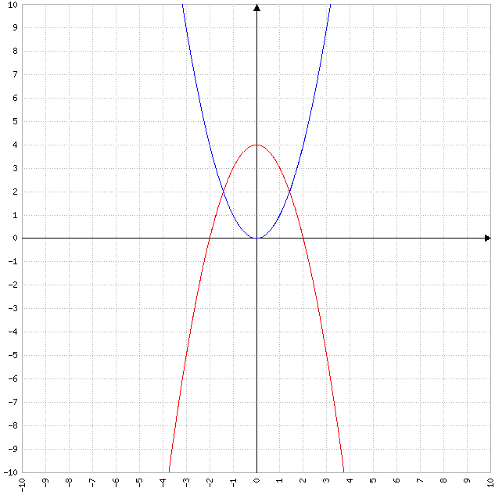

f (x)= g (x)
$x^{2}$= -$x^{2}$ + 4
$x^{2}$ + $x^{2}$= 4
2$x^{2}$= 4
$x^{2}$= $\frac{4}{2}$
$x^{2}$= 2
$\sqrt{x^{2}}$= $\sqrt{2}$
$\left|x\right|$= $\sqrt{2}$
x= $±$ $\sqrt{2}$.

Intervalo | (-$\sqrt{2}$, $\sqrt{2}$)
VP | 0
f (x) | 0
g (x) | 4

A= $\int_{-\sqrt{2}}^{\sqrt{2}}{g (x)-f (x) dx}$
A= $\int_{-\sqrt{2}}^{\sqrt{2}}{(-x^{2}+4)-x^{2} dx}$
A= $\int_{-\sqrt{2}}^{\sqrt{2}}{-x^{2}+4-x^{2} dx}$
A= $\int_{-\sqrt{2}}^{\sqrt{2}}{-2x^{2}+4 dx}$
A= $\int_{-\sqrt{2}}^{\sqrt{2}}{-2x^{2} dx}$ + $\int_{-\sqrt{2}}^{\sqrt{2}}{4 dx}$
A= -2 $\int_{-\sqrt{2}}^{\sqrt{2}}{x^{2} dx}$ + 4 $\int_{-\sqrt{2}}^{\sqrt{2}}{1 dx}$
A= -2 $\frac{x^{3}}{3}$ $|_{-\sqrt{2}}^{\sqrt{2}}$ + 4x $|_{-\sqrt{2}}^{\sqrt{2}}$
A= $\frac{-2}{3}$ [${(\sqrt{2})}^{3}$ - ${(-\sqrt{2})}^{3}$] + 4 [$\sqrt{2}$ - (-$\sqrt{2}$)]
A= $\frac{-2}{3}$ [${(\sqrt{2})}^{3}$ + ${(\sqrt{2})}^{3}$] + 4 ($\sqrt{2}$ + $\sqrt{2}$)
A= $\frac{-2}{3}$ * 2 ${(\sqrt{2})}^{3}$ + 4 * 2 $\sqrt{2}$
A= $\frac{-4}{3}$ ${(\sqrt{2})}^{2}$ $\sqrt{2}$ + 8 $\sqrt{2}$
A= $\frac{-4}{3}$ * 2 $\sqrt{2}$ + 8 $\sqrt{2}$
A= $\frac{-8}{3}$ $\sqrt{2}$ + 8 $\sqrt{2}$
A= $\frac{16}{3}$ $\sqrt{2}$.

(b) f (x)= $x^{4}$ y g (x)= x.

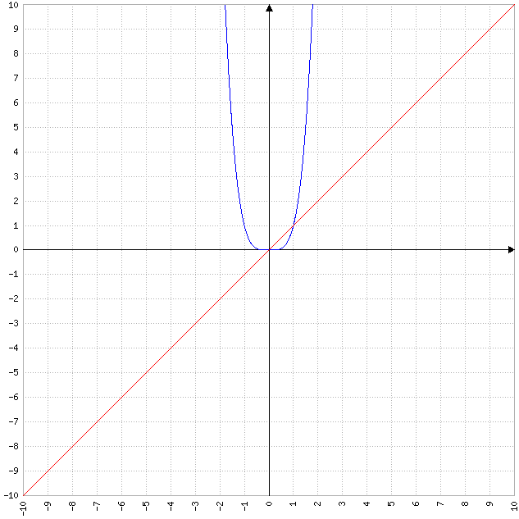

f (x)= g (x)
$x^{4}$= x
$x^{4}$ - x= 0
$x^{3}$ (x - 1)= 0.

$x_{1}$= 0; $x_{2}$= 1.

Intervalo | (0, 1)
VP | $$\frac{1}{2}$$
f (x) | $$\frac{1}{16}$$
g (x) | $$\frac{1}{2}$$

A= $\int_{0}^{1}{g (x)-f (x) dx}$
A= $\int_{0}^{1}{x-x^{4} dx}$
A= $\int_{0}^{1}{x dx}$ + $\int_{0}^{1}{-x^{4} dx}$
A= $\frac{x^{2}}{2}$ $|_{0}^{1}$ - $\int_{0}^{1}{x^{4} dx}$
A= $\frac{1}{2}$ ($1^{2}$ - $0^{2}$) - $\frac{x^{5}}{5}$ $|_{0}^{1}$
A= $\frac{1}{2}$ (1 - 0) - $\frac{1}{5}$ ($1^{5}$ - $0^{5}$)
A= $\frac{1}{2}$ * 1 - $\frac{1}{5}$ (1 - 0)
A= $\frac{1}{2}$ - $\frac{1}{5}$ * 1
A= $\frac{1}{2}$ - $\frac{1}{5}$
A= $\frac{3}{10}$.

(c) f (x)= $x^{3}$ + $\frac{1}{4}$ x y g (x)= $\frac{1}{2}$ x.

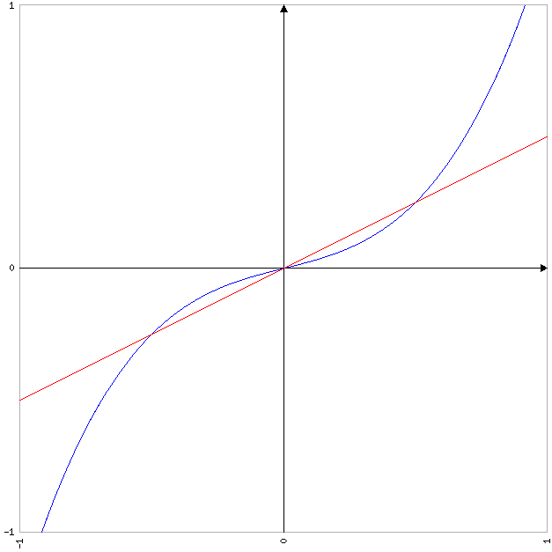

f (x)= g (x)
$x^{3}$ + $\frac{1}{4}$ x= $\frac{1}{2}$ x
$x^{3}$ + $\frac{1}{4}$ x - $\frac{1}{2}$ x= 0
$x^{3}$ - $\frac{1}{4}$ x= 0
x ($x^{2}$ - $\frac{1}{4}$)= 0.

$x_{1}$= 0; $x_{2}$= $\frac{-1}{2}$; $x_{3}$= $\frac{1}{2}$.

Intervalo | ($\frac{-1}{2}$, 0) | (0, $\frac{1}{2}$)
VP | $$\frac{-1}{4}$$ | $$\frac{1}{4}$$
f (x) | $$\frac{-5}{64}$$ | $$\frac{5}{64}$$
g (x) | $$\frac{-1}{8}$$ | $$\frac{1}{8}$$

A= $\int_{\frac{-1}{2}}^{0}{f (x)-g (x) dx}$ + $\int_{0}^{\frac{1}{2}}{g (x)-f (x) dx}$
A= $\int_{\frac{-1}{2}}^{0}{(x^{3}+\frac{1}{4}x)-\frac{1}{2}x dx}$ + $\int_{0}^{\frac{1}{2}}{\frac{1}{2}x-(x^{3}+\frac{1}{4}x) dx}$
A= $\int_{\frac{-1}{2}}^{0}{x^{3}+\frac{1}{4}x-\frac{1}{2}x dx}$ + $\int_{0}^{\frac{1}{2}}{\frac{1}{2}x-x^{3}-\frac{1}{4}x dx}$
A= $\int_{\frac{-1}{2}}^{0}{x^{3}-\frac{1}{4}x dx}$ + $\int_{0}^{\frac{1}{2}}{-x^{3}+\frac{1}{4}x dx}$
A= $\int_{\frac{-1}{2}}^{0}{x^{3} dx}$ + $\int_{\frac{-1}{2}}^{0}{\frac{-1}{4}x dx}$ + $\int_{0}^{\frac{1}{2}}{-x^{3} dx}$ + $\int_{0}^{\frac{1}{2}}{\frac{1}{4}x dx}$
A= $\int_{\frac{-1}{2}}^{0}{x^{3} dx}$ - $\frac{1}{4}$ $\int_{\frac{-1}{2}}^{0}{x dx}$ - $\int_{0}^{\frac{1}{2}}{x^{3} dx}$ + $\frac{1}{4}$ $\int_{0}^{\frac{1}{2}}{x dx}$
A= $\frac{x^{4}}{4}$ $|_{\frac{-1}{2}}^{0}$ - $\frac{1}{4}$ $\frac{x^{2}}{2}$ $|_{\frac{-1}{2}}^{0}$ - $\frac{x^{4}}{4}$ $|_{0}^{\frac{1}{2}}$ + $\frac{1}{4}$ $\frac{x^{2}}{2}$ $|_{0}^{\frac{1}{2}}$
A= $\frac{1}{4}$ [$0^{4}$ - ${(\frac{-1}{2})}^{4}$] - $\frac{1}{8}$ [$0^{2}$ - ${(\frac{-1}{2})}^{2}$] - $\frac{1}{4}$ [${(\frac{1}{2})}^{4}$ - $0^{4}$] + $\frac{1}{8}$ [${(\frac{1}{2})}^{2}$ - $0^{2}$]
A= $\frac{1}{4}$ (0 - $\frac{1}{16}$) - $\frac{1}{8}$ (0 - $\frac{1}{4}$) - $\frac{1}{4}$ ($\frac{1}{16}$ - 0) + $\frac{1}{8}$ ($\frac{1}{4}$ - 0)
A= $\frac{1}{4}$ ($\frac{-1}{16}$) - $\frac{1}{8}$ ($\frac{-1}{4}$) - $\frac{1}{4}$ $\frac{1}{16}$ + $\frac{1}{8}$ $\frac{1}{4}$
A= $\frac{-1}{64}$ + $\frac{1}{32}$ - $\frac{1}{64}$ + $\frac{1}{32}$
A= $\frac{1}{32}$.
Ejercicio 5.

Calcular el área de la región comprendida entre el eje x y el gráfico de la función f (x)= -$x^{2}$ - 1 entre -2 $≤$ x $≤$ -1.

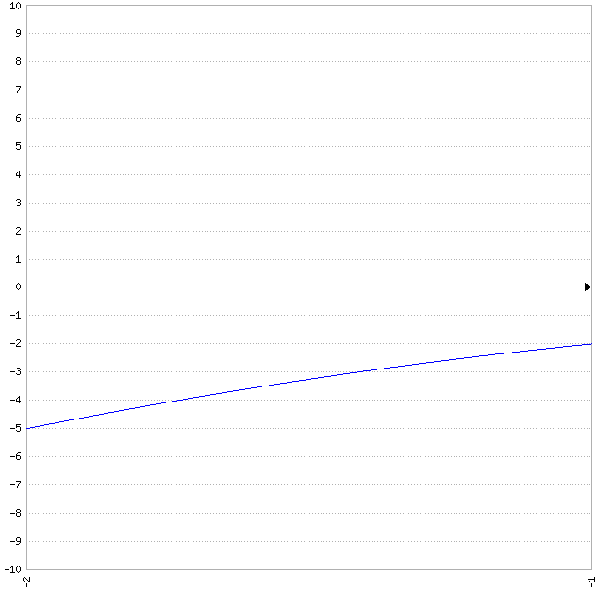

f (x)= 0
-$x^{2}$ - 1= 0
$x^{2}$ $≠$ -1.

Intervalo | (-2, -1)
VP | $$\frac{-3}{2}$$
f (x) | $<$ 0

A= -$\int_{-2}^{-1}{-x^{2}-1 dx}$
A= -($\int_{-2}^{-1}{-x^{2} dx}$ + $\int_{-2}^{-1}{-1 dx}$)
A= -(-$\int_{-2}^{-1}{x^{2} dx}$ - $\int_{-2}^{-1}{1 dx}$)
A= -($\frac{-x^{3}}{3}$ $|_{-2}^{-1}$ - x $|_{-2}^{-1}$)
A= -{$\frac{-1}{3}$ [${(-1)}^{3}$ - ${(-2)}^{3}$] - [-1 - (-2)]}
A= -{$\frac{-1}{3}$ [-1 - (-8)] - (-1 + 2)}
A= -[$\frac{-1}{3}$ (-1 + 8) - 1]
A= -($\frac{-1}{3}$ * 7 - 1)
A= -($\frac{-7}{3}$ - 1)
A= -($\frac{-10}{3}$)
A= $\frac{10}{3}$.
Ejercicio 6.

Calcular el área de la región comprendida entre el eje x y el gráfico de la función f (x)= $x^{2}$ + 2x - 3 entre -1 $≤$ x $≤$ 2.

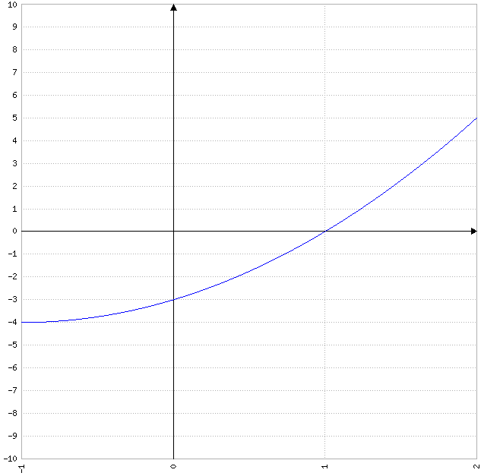

f (x)= 0
$x^{2}$ + 2x - 3= 0.

$x_{1}$, $x_{2}$= $\frac{-2±\sqrt{2^{2}-4*1(-3)}}{2*1}$
$x_{1}$, $x_{2}$= $\frac{-2±\sqrt{4+12}}{2}$
$x_{1}$, $x_{2}$= $\frac{-2±\sqrt{16}}{2}$
$x_{1}$, $x_{2}$= $\frac{-2±4}{2}$
$x_{1}$= $\frac{-2+4}{2}$= $\frac{2}{2}$= 1.
$x_{2}$= $\frac{-2-4}{2}$= $\frac{-6}{2}$= -3.

Intervalo | (-1, 1) | (1, 2)
VP | 0 | $$\frac{3}{2}$$
f (x) | $<$ 0 | $>$ 0

A= -$\int_{-1}^{1}{x^{2}+2x-3 dx}$ + $\int_{1}^{2}{x^{2}+2x-3 dx}$
A= -($\int_{-1}^{1}{x^{2} dx}$ + $\int_{-1}^{1}{2x dx}$ + $\int_{-1}^{1}{-3 dx}$) + ($\int_{1}^{2}{x^{2} dx}$ + $\int_{1}^{2}{2x dx}$ + $\int_{1}^{2}{-3 dx}$)
A= -($\frac{x^{3}}{3}$ $|_{-1}^{1}$ + 2 $\int_{-1}^{1}{x dx}$ - 3 $\int_{-1}^{1}{1 dx}$) + ($\frac{x^{3}}{3}$ $|_{1}^{2}$ + 2 $\int_{1}^{2}{x dx}$ - 3 $\int_{1}^{2}{1 dx}$)
A= -{$\frac{1}{3}$ [$1^{3}$ - ${(-1)}^{3}$] + 2 $\frac{x^{2}}{2}$ $|_{-1}^{1}$ - 3x $|_{-1}^{1}$} + [$\frac{1}{3}$ ($2^{3}$ - $1^{3}$) + 2 $\frac{x^{2}}{2}$ $|_{1}^{2}$ - 3x $|_{1}^{2}$]
A= -{$\frac{1}{3}$ [1 - (-1)] + [$1^{2}$ - ${(-1)}^{2}$] - 3 [1 - (-1)]] + [$\frac{1}{3}$ (8 - 1) + ($2^{2}$ - $1^{2}$) - 3 (2 - 1)]
A= -[$\frac{1}{3}$ (1 + 1) + (1 - 1) - 3 (1 + 1)] + [$\frac{1}{3}$ * 7 + (4 - 1) - 3 * 1]
A= -($\frac{1}{3}$ * 2 + 0 - 3 * 2) + ($\frac{7}{3}$ + 3 - 3)
A= -($\frac{2}{3}$ + 0 - 6) + $\frac{7}{3}$
A= -($\frac{-16}{3}$) + $\frac{7}{3}$
A= $\frac{16}{3}$ + $\frac{7}{3}$
A= $\frac{23}{3}$.
Ejercicio 7.

Calcular el área de la región comprendida entre los gráficos de f (x)= $x^{2}$ + 1 y g (x)= 2$x^{2}$ para 0 $≤$ x $≤$ 2.

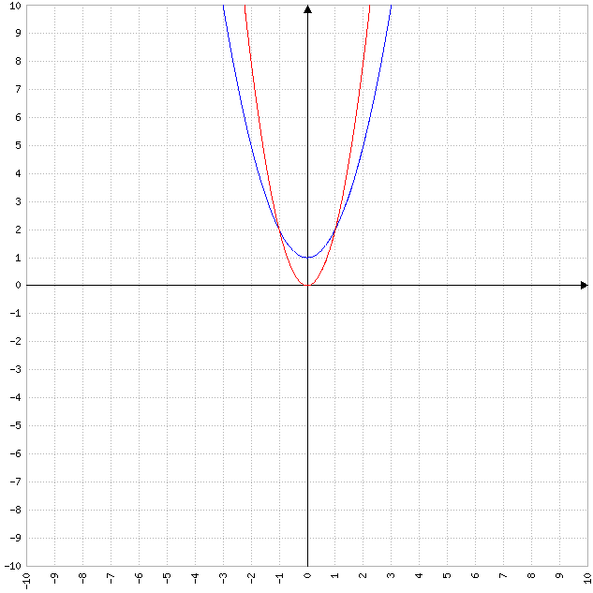

f (x)= g (x)
$x^{2}$ + 1= 2$x^{2}$
2$x^{2}$ - $x^{2}$= 1
$x^{2}$= 1
$\sqrt{x^{2}}$= $\sqrt{1}$
$\left|x\right|$= 1
x= $±$1.

Intervalo | (-1, 1)
VP | 0
f (x) | 1
g (x) | 0

A= $\int_{-1}^{1}{(x^{2}+1)-2x^{2} dx}$
A= $\int_{-1}^{1}{x^{2}+1-2x^{2} dx}$
A= $\int_{-1}^{1}{-x^{2}+1 dx}$
A= $\int_{-1}^{1}{-x^{2} dx}$ + $\int_{-1}^{1}{1 dx}$
A= -$\int_{-1}^{1}{x^{2} dx}$ + x $|_{-1}^{1}$
A= $\frac{-x^{3}}{3}$ $|_{-1}^{1}$ + [1 - (-1)]
A= $\frac{-1}{3}$ [$1^{3}$ - ${(-1)}^{3}$] + (1 + 1)
A= $\frac{-1}{3}$ [1 - (-1)] + 2
A= $\frac{-1}{3}$ (1 + 1) + 2
A= $\frac{-1}{3}$ * 2 + 2
A= $\frac{-2}{3}$ + 2
A= $\frac{4}{3}$.
Ejercicio 8.

Hallar f (x) sabiendo que f´ (x)= x + $\frac{1}{x^{2}}$ y f (1)= 1.

f (x)= $\int{f´ (x) dx}$
f (x)= $\int{x+\frac{1}{x^{2}} dx}$
f (x)= $\int{x dx}$ + $\int{\frac{1}{x^{2}} dx}$
f (x)= $\frac{x^{2}}{2}$ + $\int{x^{-2} dx}$
f (x)= $\frac{x^{2}}{2}$ + $\frac{x^{-1}}{-1}$
f (x)= $\frac{1}{2}$ $x^{2}$ - $\frac{1}{x}$ + C.

f (1)= 1
$\frac{1}{2}$ * $1^{2}$ - $\frac{1}{1}$ + C= 1
$\frac{1}{2}$ * 1 - 1 + C= 1
$\frac{1}{2}$ - 1 + C= 1
$\frac{-1}{2}$ + C= 1
C= 1 + $\frac{1}{2}$
C= $\frac{3}{2}$.

f (x)= $\frac{1}{2}$ $x^{2}$ - $\frac{1}{x}$ + $\frac{3}{2}$.
Ejercicio 9.

Sabiendo que f´ (x)= 3$x^{2}$ - 8x + 2 y, además, que f (3)= -4, hallar la función f (x).

f (x)= $\int{f´ (x) dx}$
f (x)= $\int{3x^{2}-8x+2 dx}$
f (x)= $\int{3x^{2} dx}$ + $\int{-8x dx}$ + $\int{2 dx}$
f (x)= 3 $\int{x^{2} dx}$ - 8 $\int{x dx}$ + 2 $\int{1 dx}$
f (x)= 3 $\frac{x^{3}}{3}$ - 8 $\frac{x^{2}}{2}$ + 2x
f (x)= $x^{3}$ - 4$x^{2}$ + 2x + C.

f (3)= -4
$3^{3}$ - 4 * $3^{2}$ + 2 * 3 + C= -4
27 - 4 * 9 + 6 + C= -4
27 - 36 + 6 + C= -4
-3 + C= -4
C= -4 + 3
C= -1.

f (x)= $x^{3}$ - 4$x^{2}$ + 2x - 1.
Ejercicio 10.

Hallar todas las funciones cuya derivada es g´ (x)= $x^{2}$ cos x.

g (x)= $\int{g´ (x) dx}$
g (x)= $\int{x^{2}\cos{x}dx}$
g (x)= $x^{2}$ sen x - $\int{sen x*2x dx}$ (*)
g (x)= $x^{2}$ sen x - 2 $\int{x sen x dx}$
g (x)= $x^{2}$ sen x - 2 [x (-cos x) - $\int{-\cos{x}dx}$] (**)
g (x)= $x^{2}$ sen x - 2 (-x cos x + $\int{\cos{x}dx}$)
g (x)= $x^{2}$ sen x - 2 (-x cos x + sen x)
g (x)= $x^{2}$ sen x - 2x cos x - 2 sen x
g (x)= ($x^{2}$ - 2) sen x - 2x cos x + C.

(*) u= $x^{2}$; du= 2x dx; dv= cos x dx; v= sen x.
(**) u= x; du= dx; dv= sen x; v= -cos x.
Ejercicio 11.

Sea g´´ (x)= 2$x^{3}$ - 4$x^{7}$, g´ (1)= -2 y g (0)= 0, hallar la función g (x).

g´ (x)= $\int{g´´ (x) dx}$
g´ (x)= $\int{2x^{3}-4x^{7} dx}$
g´ (x)= $\int{2x^{3} dx}$ + $\int{-4x^{7} dx}$
g´ (x)= 2 $\int{x^{3} dx}$ - 4 $\int{x^{7} dx}$
g´ (x)= 2 $\frac{x^{4}}{4}$ - 4 $\frac{x^{8}}{8}$
g´ (x)= $\frac{1}{2}$ $x^{4}$ - $\frac{1}{2}$ $x^{8}$
g´ (x)= $\frac{1}{2}$ ($x^{4}$ - $x^{8}$) + C.

g´ (1)= -2
$\frac{1}{2}$ ($1^{4}$ - $1^{8}$) + C= -2
$\frac{1}{2}$ (1 - 1) + C= -2
$\frac{1}{2}$ * 0 + C= -2
0 + C= -2
C= -2.

g´ (x)= $\frac{1}{2}$ ($x^{4}$ - $x^{8}$) - 2.

g (x)= $\int{g´ (x) dx}$
g (x)= $\int{\frac{1}{2}(x^{4}-x^{8})-2 dx}$
g (x)= $\int{\frac{1}{2}x^{4}-\frac{1}{2}x^{8}-2 dx}$
g (x)= $\int{\frac{1}{2}x^{4} dx}$ + $\int{\frac{-1}{2}x^{8} dx}$ + $\int{-2 dx}$
g (x)= $\frac{1}{2}$ $\int{x^{4} dx}$ - $\frac{1}{2}$ $\int{x^{8} dx}$ - 2 $\int{1 dx}$
g (x)= $\frac{1}{2}$ $\frac{x^{5}}{5}$ - $\frac{1}{2}$ $\frac{x^{9}}{9}$ - 2x
g (x)= $\frac{1}{10}$ $x^{5}$ - $\frac{1}{18}$ $x^{9}$ - 2x + C.

g (0)= 0
$\frac{1}{10}$ $0^{5}$ - $\frac{1}{18}$ $0^{9}$ - 2 * 0 + C= 0
$\frac{1}{10}$ * 0 - $\frac{1}{18}$ * 0 - 0 + C= 0
0 - 0 - 0 + C= 0
C= 0.

g (x)= $\frac{1}{10}$ $x^{5}$ - $\frac{1}{18}$ $x^{9}$ - 2x.

